GARAGE MANAGEMENT SYSTEM

College Name: Government Arts College Coimbatore

College Code : bru0012

Team ID :NM2025TMID23424

TEAM LEADER NAME: **UTHRAN G S**

EMAIL: [uthiranuthiran22@gmail.com](mailto:uthiranuthiran22@gmail.com)

TEAM MEMBER: SHARAN M

EMAIL: [sharanmuthu00@gmail.com](mailto:sharanmuthu00@gmail.com)

TEAM MEMBER: ESWARA PANDIYAN C

EMAIL: [pandieswara74@gmail.com](mailto:pandieswara74@gmail.com)

TEAM MEMBER: SARATH KUMAR D

EMAIL: [dsk.sarathkumar2005@gmail.com](mailto:dsk.sarathkumar2005@gmail.com)

TEAM MEMBER: MANOJ M

EMAIL: [manojm071104@gmail.com](mailto:manojm071104@gmail.com)

INTRODUCTION

* 1. Project Overview

**Garage Management system**

The Garage Management System is a valuable tool for automotive repair facilities, helping them deliver top-notch service, increase operational efficiency, and build lasting customer relationships. With its user-friendly interface and powerful features, GMS empowers garages to thrive in a competitive market while ensuring a seamless and satisfying experience for both customers and staff.

Billing and feedback

Customer Details

Garage Management System

Appointment

Service Records

aaaaaa

1.2 DEVELOPMENT PHASE

* Creating developer Account:

By using this URL - <https://developer.salesforce.com/signup>

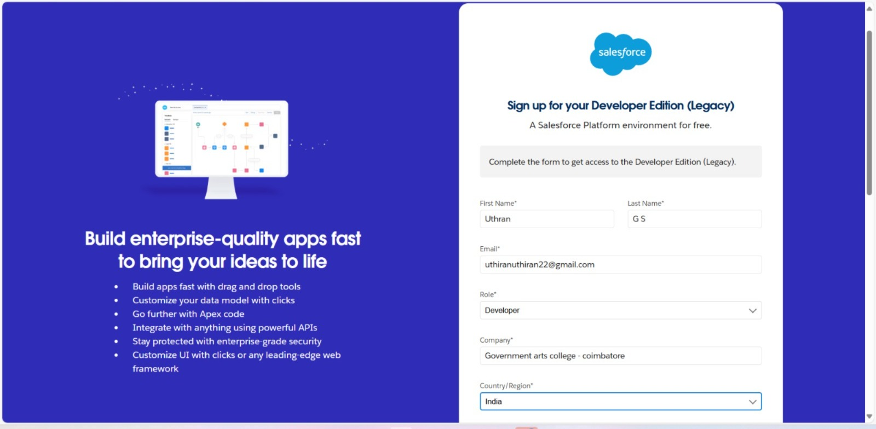

* 1. Creating Objects

1. **Customer Details**
2. **Appointment**
3. **Service Records**
4. **Billing and Feedback**

**1.Customer object**

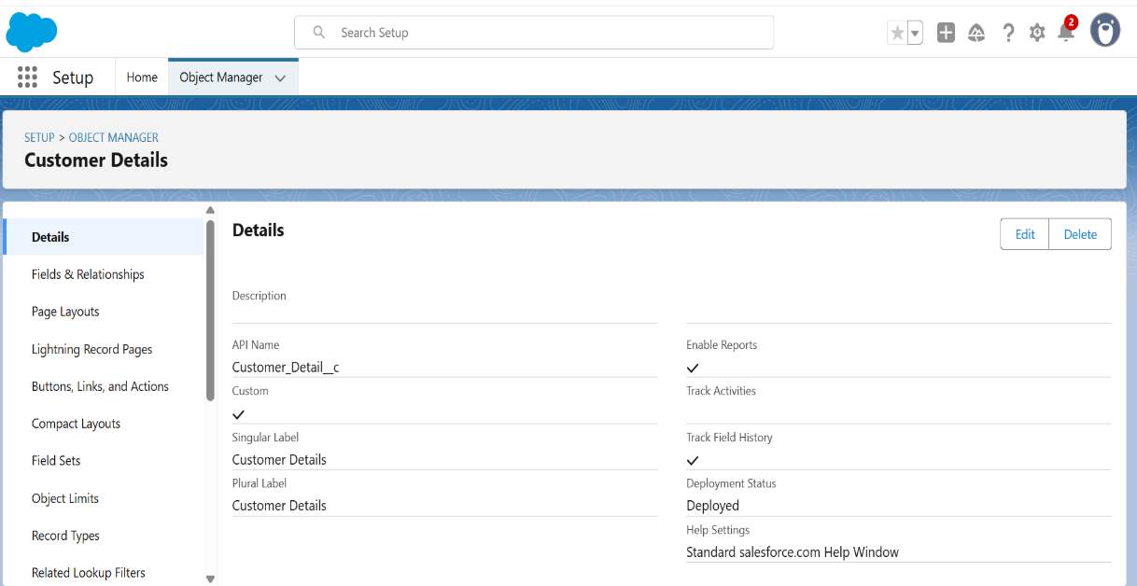

1. **Appointment object**

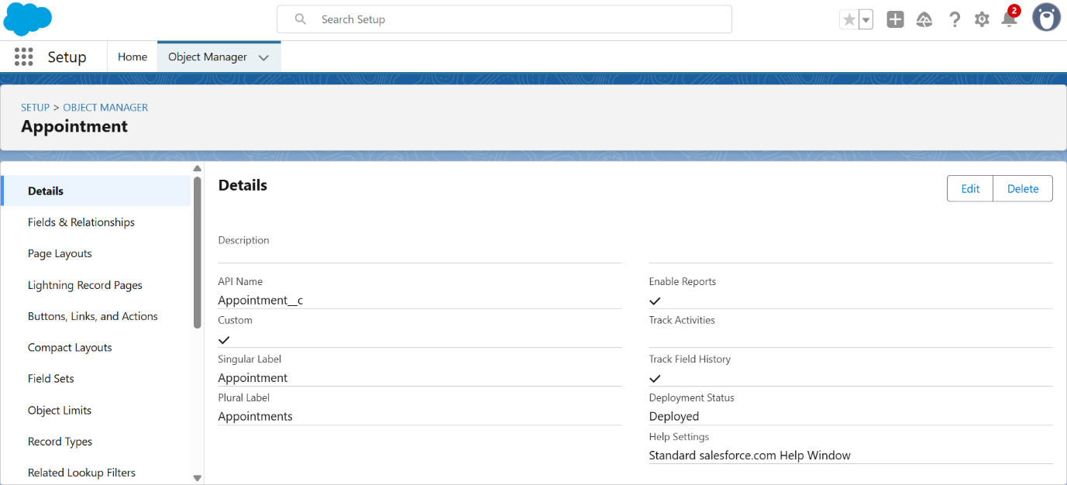

1. Service Record Object

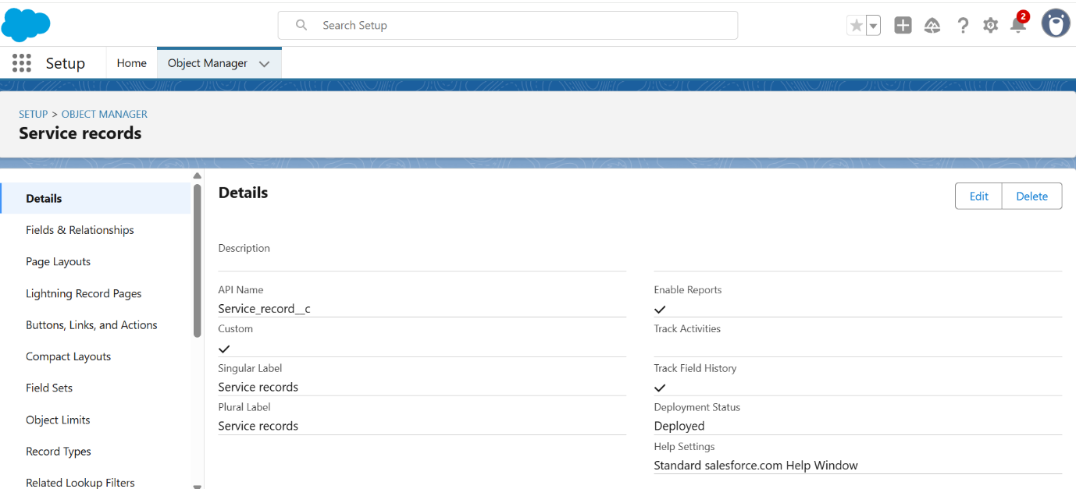

1. Billing and Feedback Object

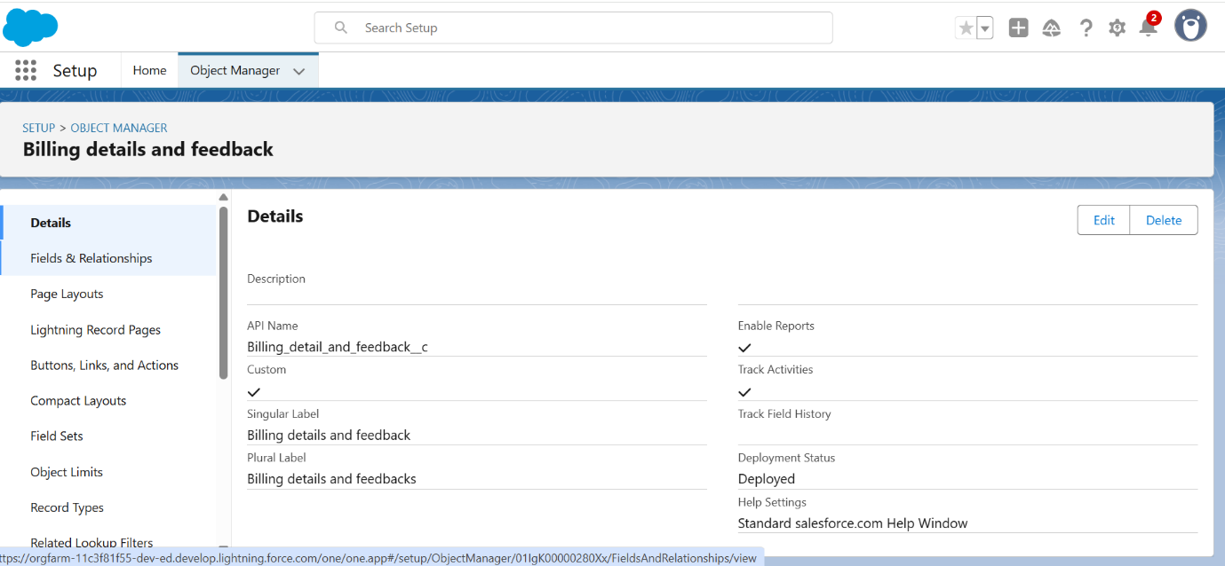

1.3 CREATING CUSTOM TABS

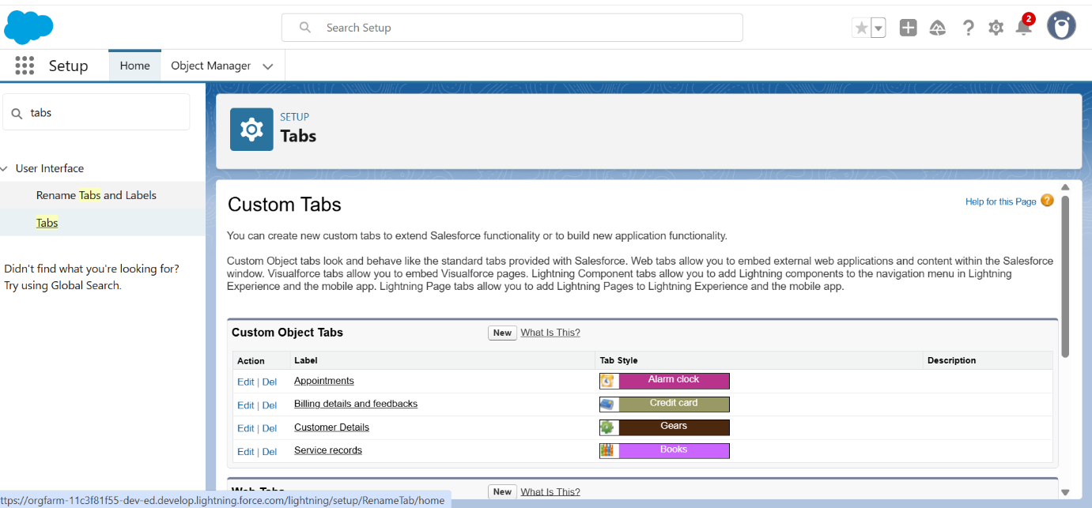

1.3 CREATING LIGHTNING APP

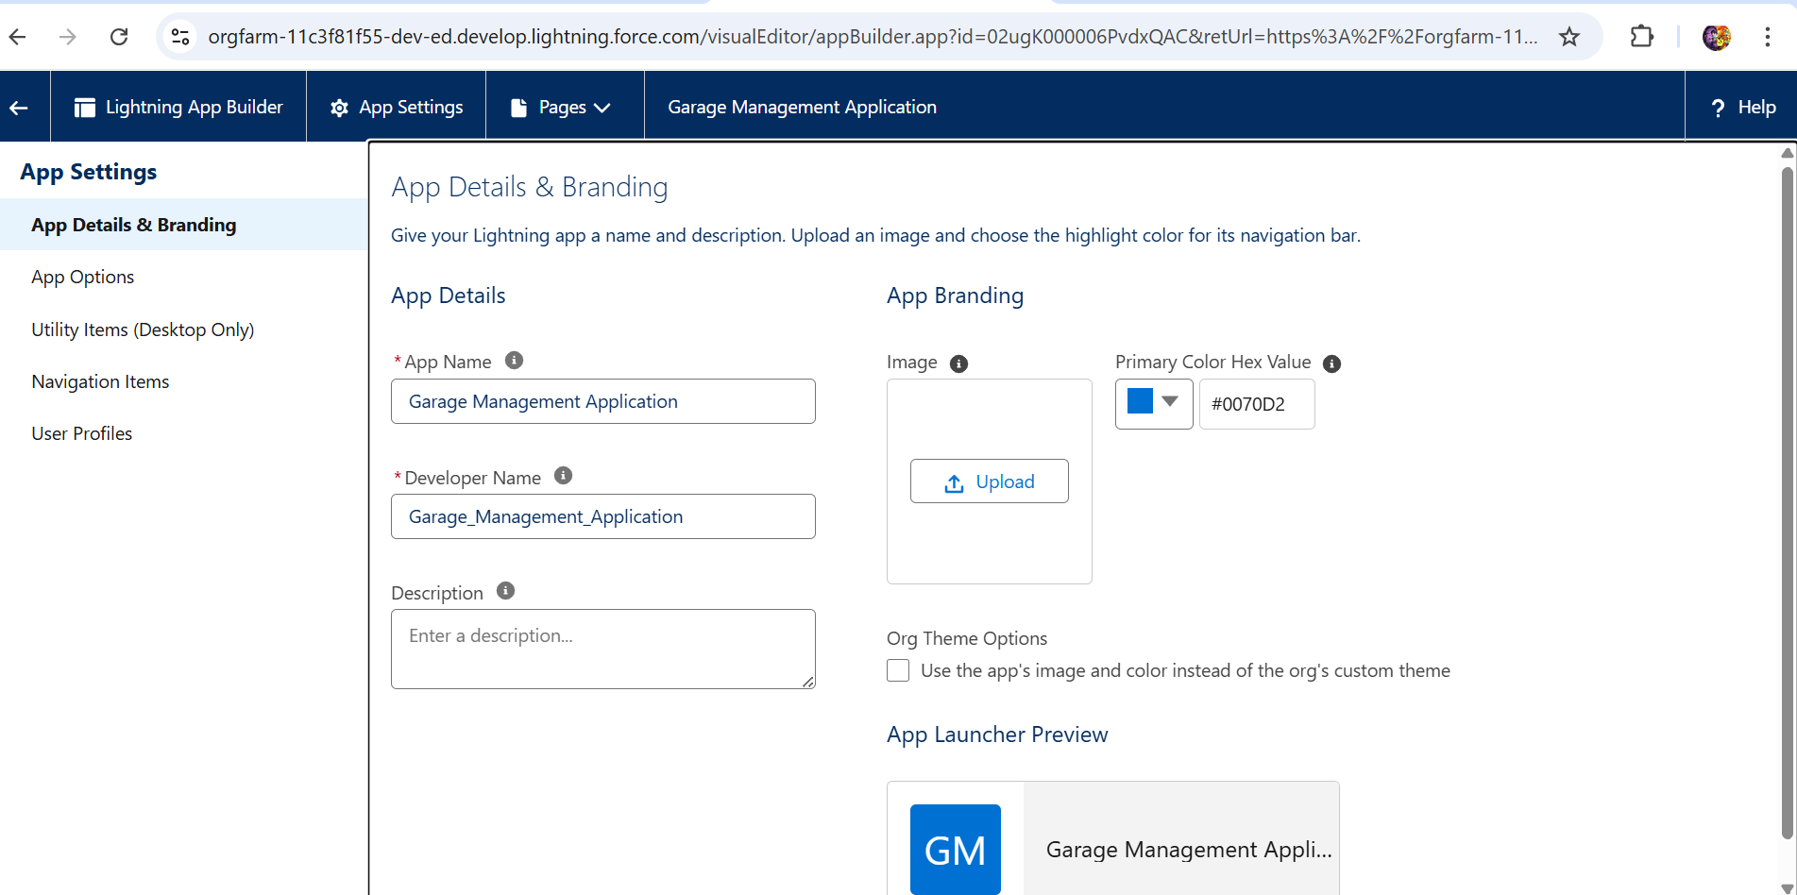

1.4 Configuring fields and relationships

* 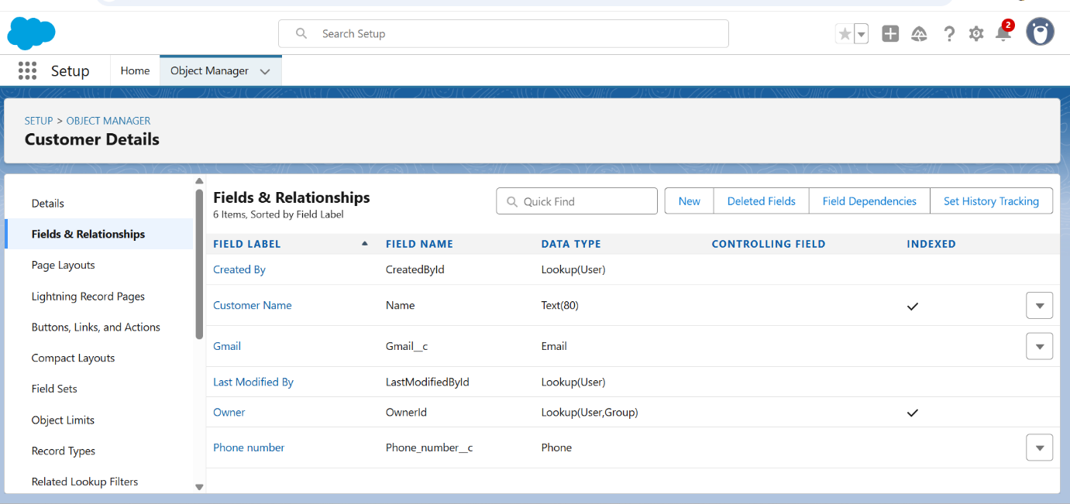

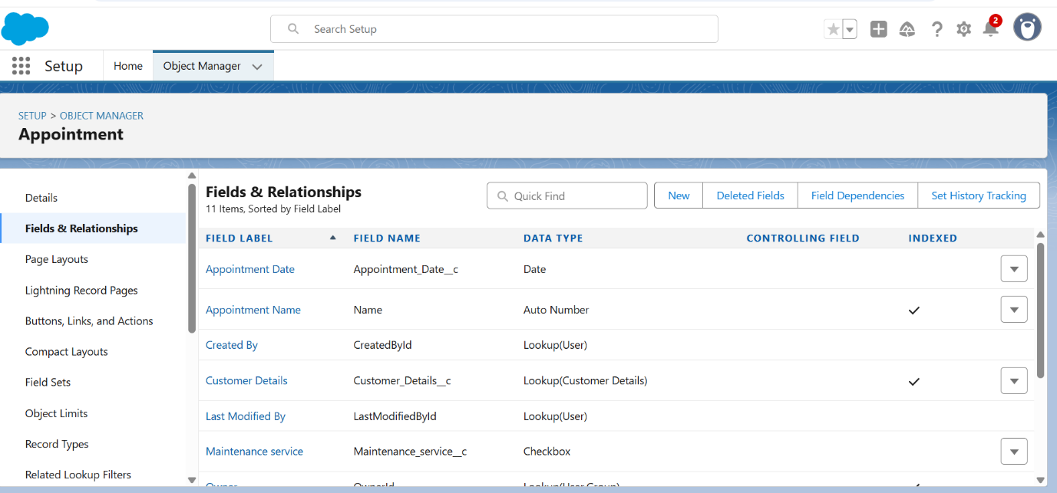

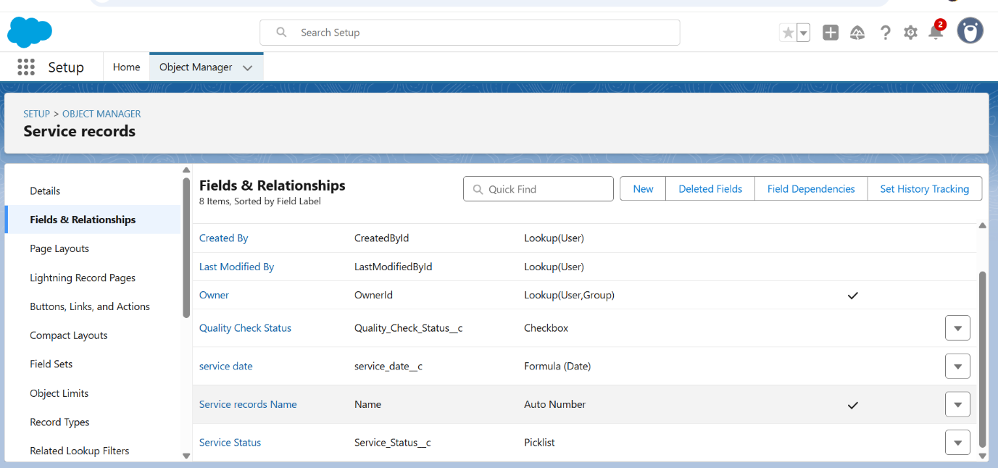

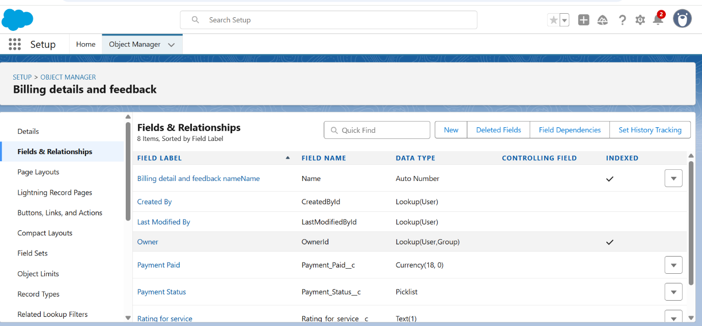

1.5 **To create a validation rule**

* **To an Appointment Object**

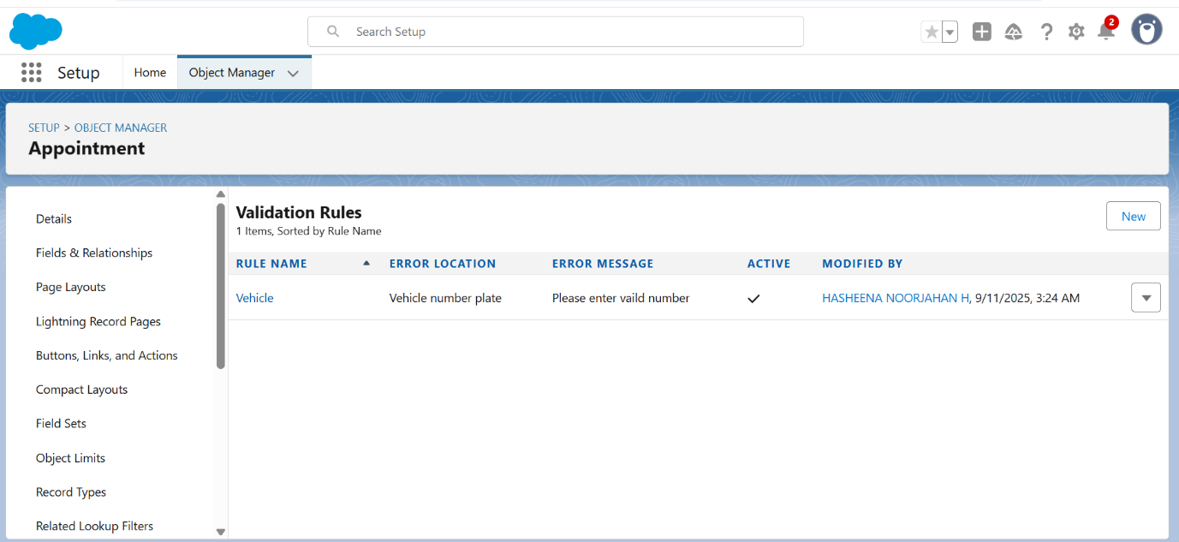

* **To an Billing and feedback Object**

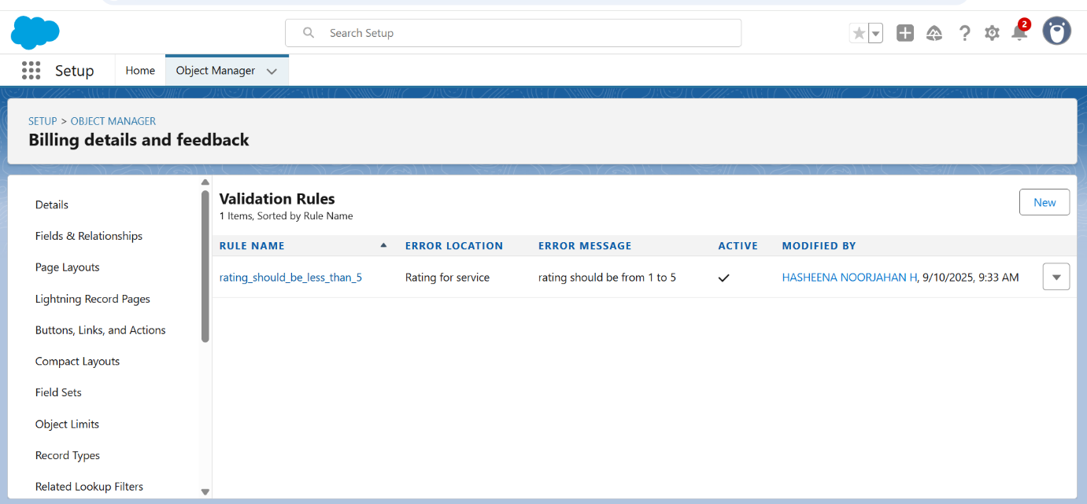

**1.6 DUPLICATE RULE**

* ***To create a matching rule to an Customer details Object***

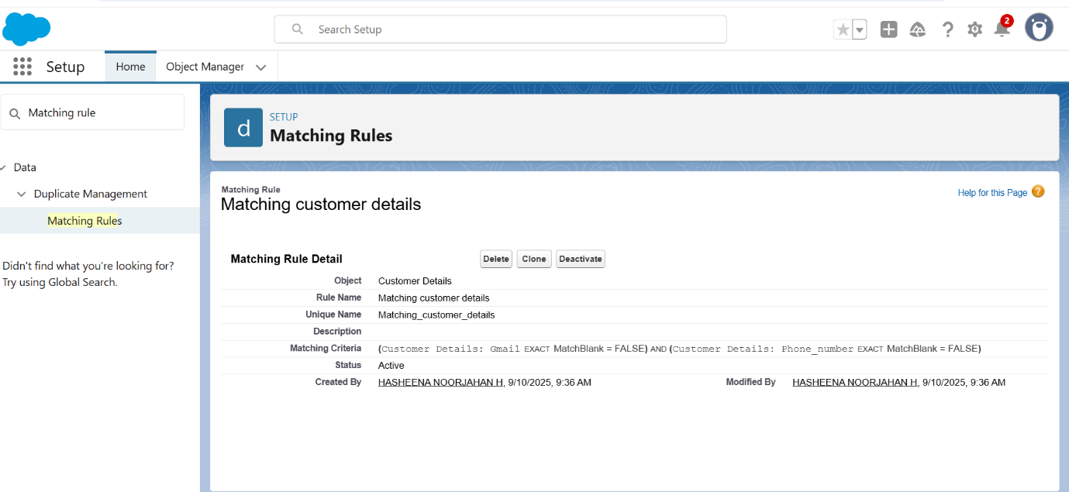

* ***To create a Duplicate rule to an Customer details Object***

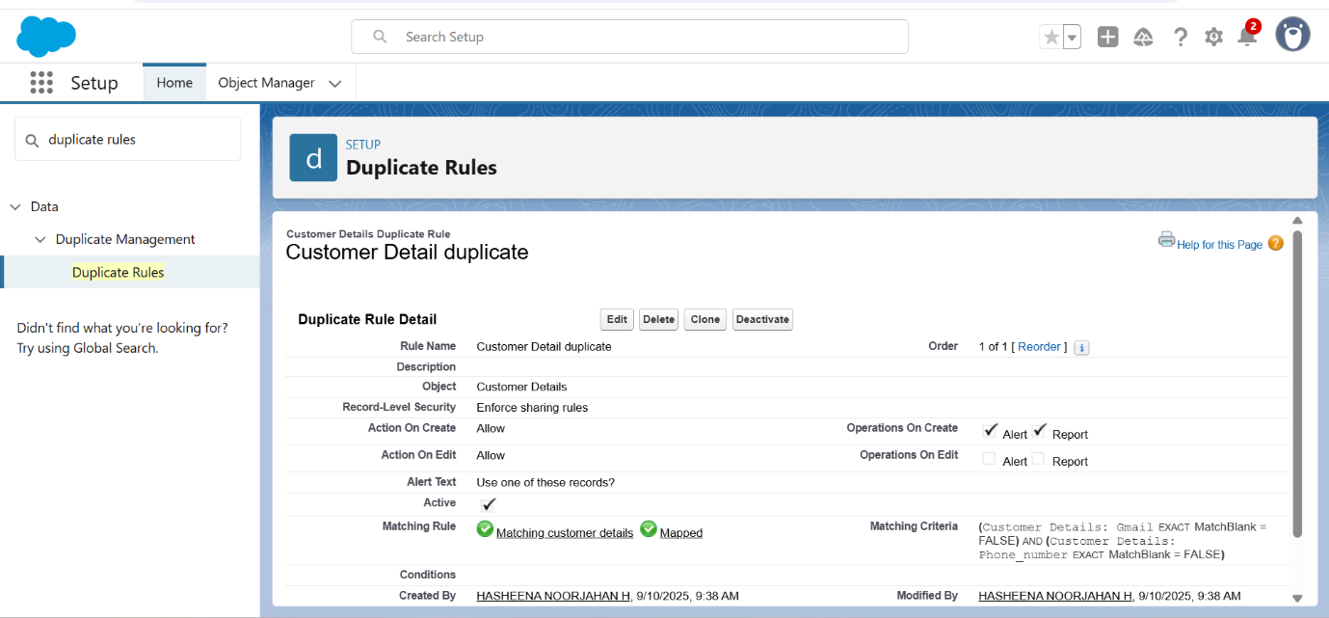

**1.7 PROFILES**

* ***Creating Manager Profile***

* ***Creating sales person profile***

**1.8 ROLE & ROLE HIERARCHY**

* ***Creating Manager Role & Another roles*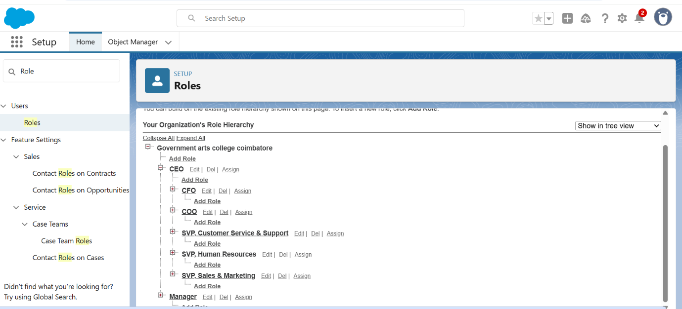**

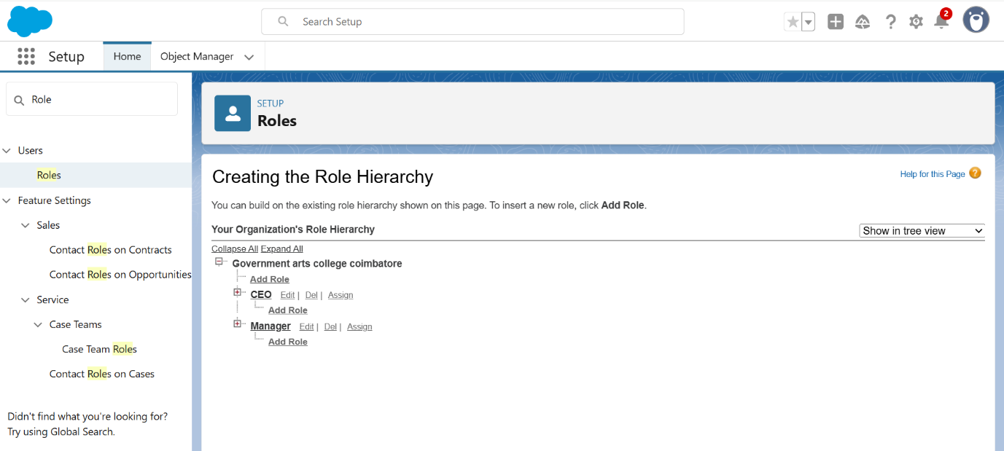

**1.9 USERS**

* ***Creating users***

**1.10 PUBLIC GROUPS**

* ***Creating New Public Group***

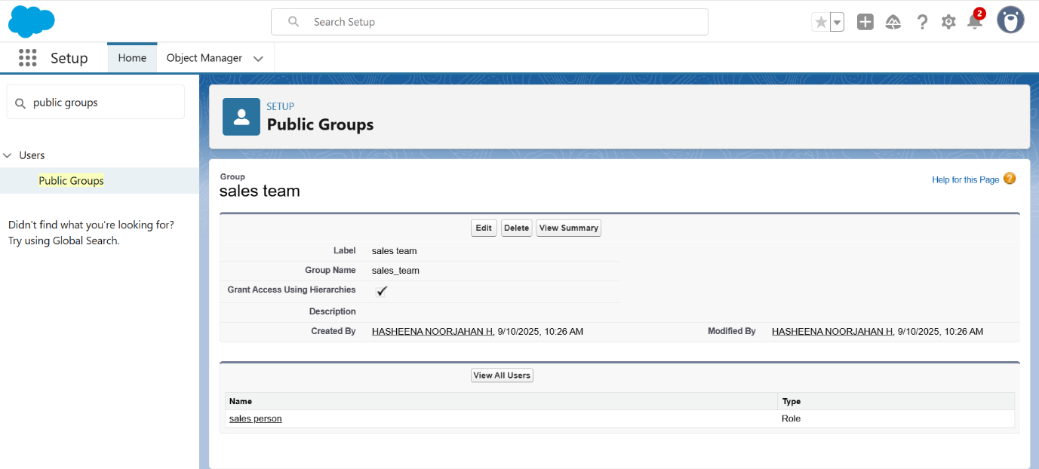

**1.12 SHARING SETTING**

* ***Create Sharing settings***

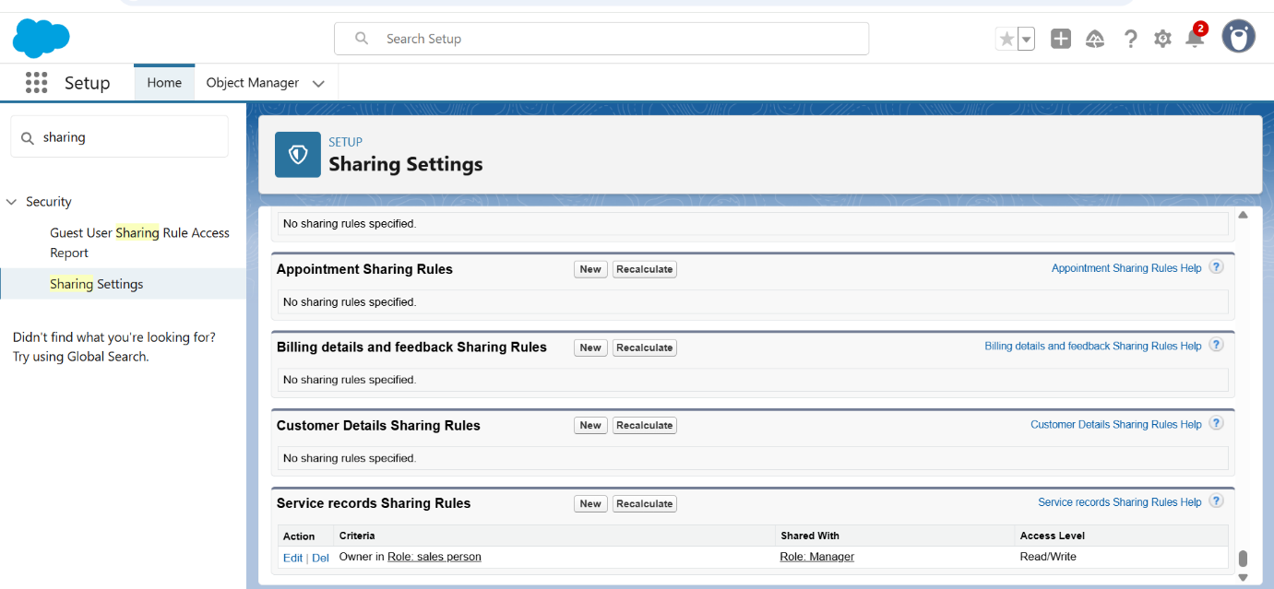

**1.13 FLOWS**

* ***Creating Billing flow & Another Flow***

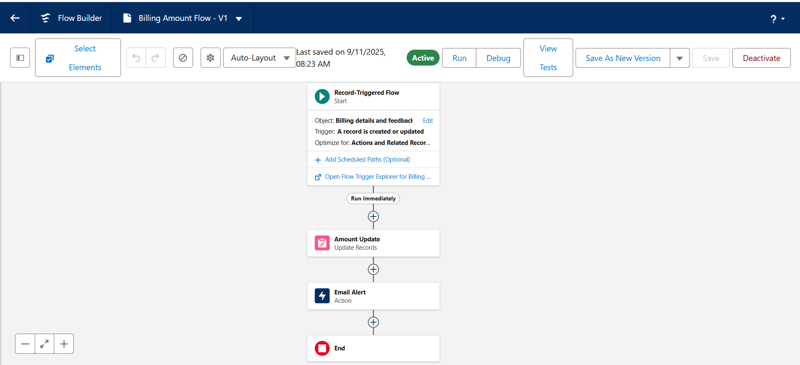

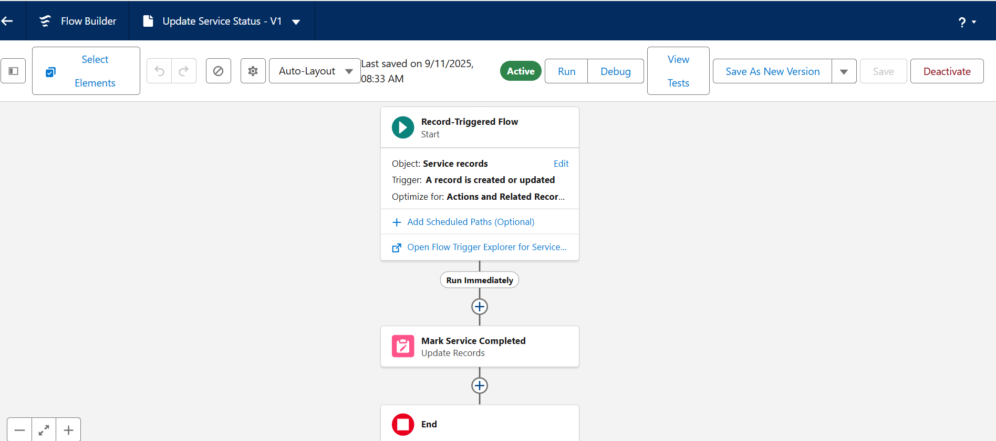

**1.14 APEX TRIGGER**

* ***Apex Handler***

***ApexDistributionHandler***

***Code:***

***public class AmountDistributionHandler {***

***public static void amountDist(list<Appointment__c> listApp){***

***list<Service_records__c> serList = new list <Service_records__c>(); for(Appointment__c app : listApp){***

***if(app.Maintenance_service__c == true && app.Repairs__c == true && app.Replacement_Parts__c == true***

***app.Service_Amount__c = 10000;***

***}***

***else if(app.Maintenance_service__c == true && app.Repairs__c == true){***

***app.Service_Amount__c = 500***

***else if(app.Maintenance_service__c == true && app.Replacement_Parts__c == true){***

***app.Service_Amount__c = 8000;***

***}***

***else if(app.Repairs__c == true && app.Replacement_Parts__c == true){***

***app.Service_Amount__c = 7000;***

***}***

***else if(app.Maintenance_service__c == true){***

***app.Service_Amount__c = 2000;***

***}***

***else if(app.Repairs__c == true){***

***app.Service_Amount__c = 3000;***

***}***

***else if(app.Replacement_Parts__c == true){***

***app.Service_Amount__c = 5000;***

***}}}}***

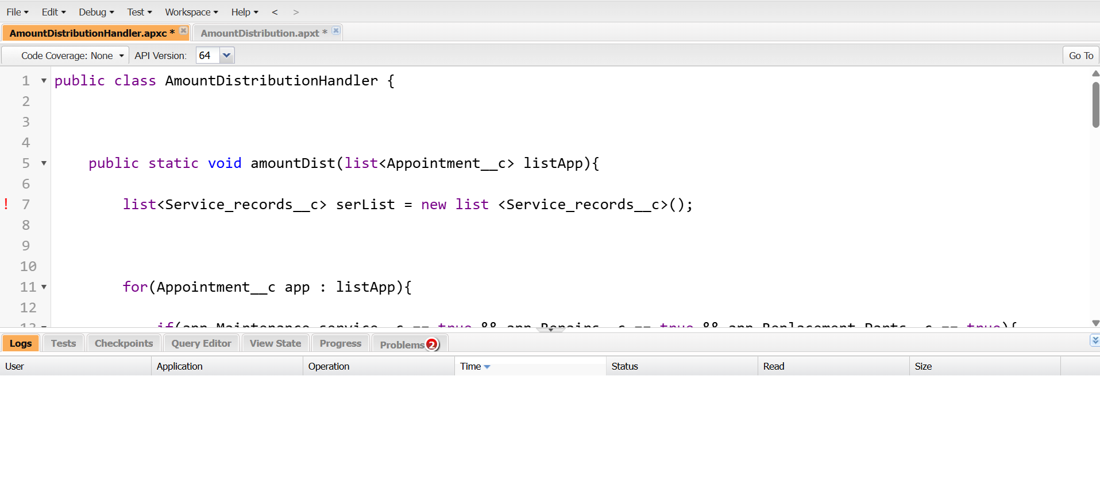

***ApexDistribution***

***Code:***

***trigger AmountDistribution on Appointment__c (before insert, before update) {***

***if(trigger.isbefore && trigger.isinsert || trigger.isupdate){***

***AmountDistributionHandler.amountDist(trigger.new);***

***}***

***}***

**1.15 REPORTS**

* ***Create a Report Folder***

* ***Sharing a Report Folder***

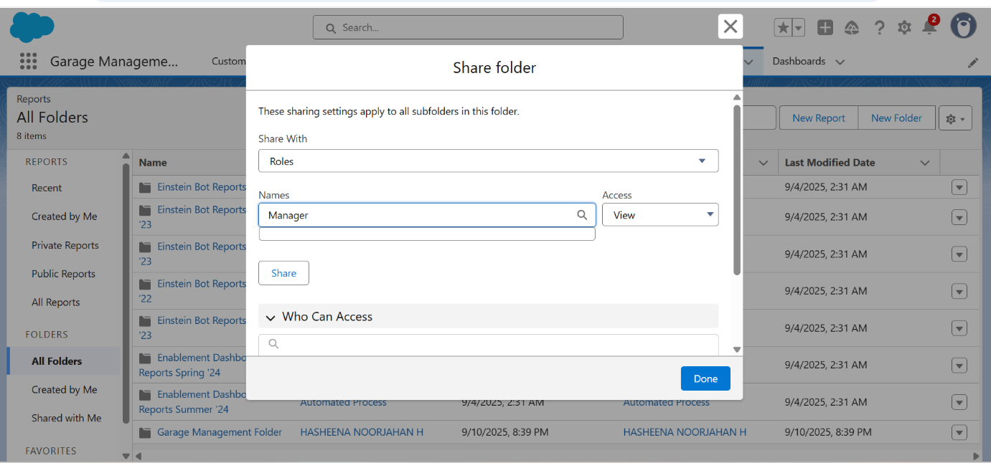

* ***Create a Report Type***

* ***Create a Report***

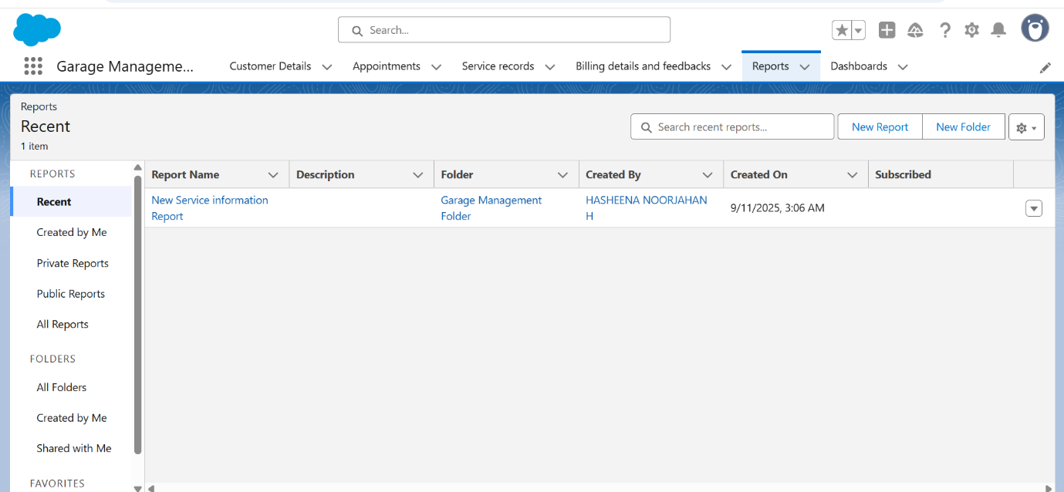

**1.16 DASHBOARD**

* ***Creating Dashboard & Dashboard Folder***

**1.17 USER ADOPTION**

* ***Creating Records***

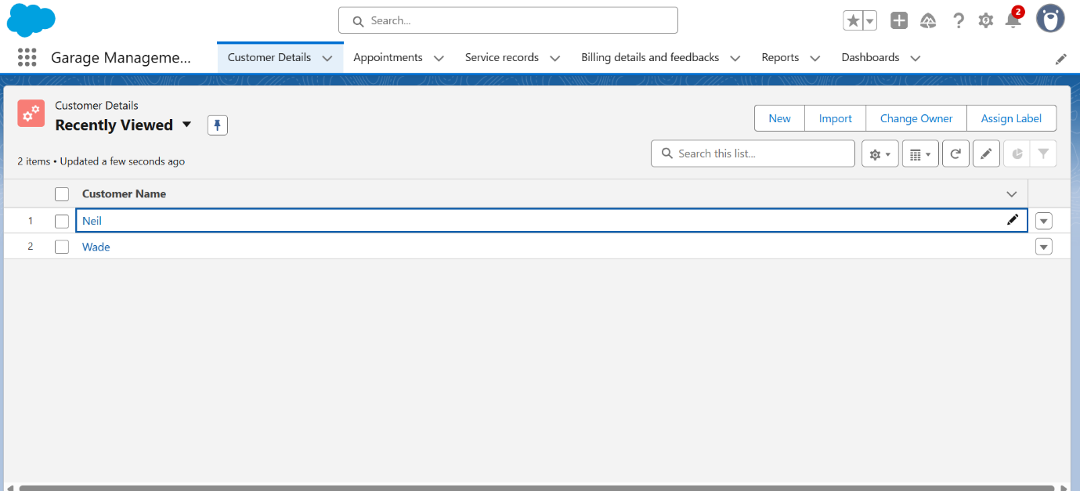

**CONCLUSION**

**The conclusion of effective garage management is achieving a competitive advantage through increased operational efficiency, streamlined workflows, and enhanced customer satisfaction by leveraging digital systems like**[**Garage Management Systems (GMS)**](https://www.google.com/search?q=Garage+Management+Systems+%28GMS%29&oq=conculsion+of+garagemanagement&gs_lcrp=EgZjaHJvbWUyBggAEEUYOTIHCAEQIRigATIHCAIQIRiPAjIHCAMQIRiPAtIBCTE2MTkyajBqN6gCCLACAfEFtfQETrk51eY&sourceid=chrome&ie=UTF-8&mstk=AUtExfDW0aETYTFvNq5h8gzldPgA6o79_Vicf1nqCfTBzU5eGdF8UuqcuVzALKlF14gHBTL1Qxt1d_NiFKkaakPCiv720Vz8kpQnwZxUd5Tuo2sRd9b9CJD_uMxnWoi4D6YDToqkZSOt5xeRDOC6z2DS53PiJxcBYp80RgIALXGyXiEit8Y&csui=3&ved=2ahUKEwiF4ZGFp9iPAxXTxTgGHflIKWcQgK4QegQIARAC)**.**